OnlineLibrary

Software Architecture Document

Version 1.0

Revision History

|  |  |  |  |
| --- | --- | --- | --- |
| **Date** | **Version** | **Description** | **Author** |
| 30/11/2013 | 1.0 | Software Architecture Document | Torsten, Wanping |
|  |  |  |  |
|  |  |  |  |
|  |  |  |  |

Table of Contents

1. Introduction 4

1.1 Purpose 4

1.2 Scope 4

1.3 Definitions, Acronyms, and Abbreviations 4

1.4 References 4

1.5 Overview 4

2. Architectural Representation 4

3. Architectural Goals and Constraints 4

4. Use-Case View 4

4.1 Use-Case Realizations 5

5. Logical View 5

5.1 Overview 5

5.2 Architecturally Significant Design Packages 5

6. Process View 6

7. Deployment View 6

8. Data View (optional) 6

9. Size and Performance 6

10. Quality 6

Software Architecture Document

# Introduction

## Purpose

This document provides a comprehensive architectural overview of the system, using a number of different architectural views to depict different aspects of the system. It is intended to capture and convey the significant architectural decisions which have been made on the system.

## Scope

[A brief description of what the Software Architecture Document applies to; what is affected or influenced by this document.]

## Definitions, Acronyms, and Abbreviations

[This subsection provides the definitions of all terms, acronyms, and abbreviations required to properly interpret the **Software Architecture Document**.  This information may be provided by reference to the project’s Glossary.]

## References

[This subsection provides a complete list of all documents referenced elsewhere in the **Software Architecture Document**. Identify each document by title, report number (if applicable), date, and publishing organization. Specify the sources from which the references can be obtained. This information may be provided by reference to an appendix or to another document.]

## Overview

[This subsection describes what the rest of the **Software Architecture Document** contains and explains how the **Software Architecture Document** is organized.]

# Architectural Representation

[This section describes what software architecture is for the current system, and how it is represented. Of the **Use-Case**, **Logical**, **Process**, **Deployment**, and **Implementation Views**, it enumerates the views that are necessary, and for each view, explains what types of model elements it contains.]

# Architectural Goals and Constraints

[This section describes the software requirements and objectives that have some significant impact on the architecture; for example, safety, security, privacy, use of an off-the-shelf product, portability, distribution, and reuse. It also captures the special constraints that may apply: design and implementation strategy, development tools, team structure, schedule, legacy code, and so on.]

Write here which external interfaces and dependencies you have.

Make sure to include external systems and libraries in your diagrams below.

# Use-Case View

See SRS

## Use-Case Realizations

See SRS

# Logical View

[This section describes the architecturally significant parts of the design model, such as its decomposition into subsystems and packages. And for each significant package, its decomposition into classes and class utilities. You should introduce architecturally significant classes and describe their responsibilities, as well as a few very important relationships, operations, and attributes.]

## Overview

[This subsection describes the overall decomposition of the design model in terms of its package hierarchy and layers.]

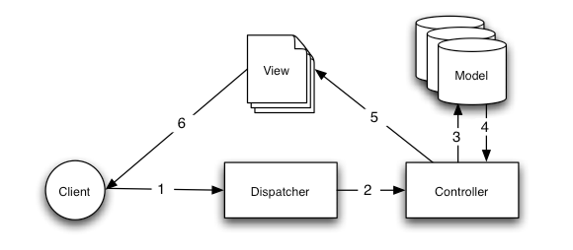

## Architecturally Significant Design Packages

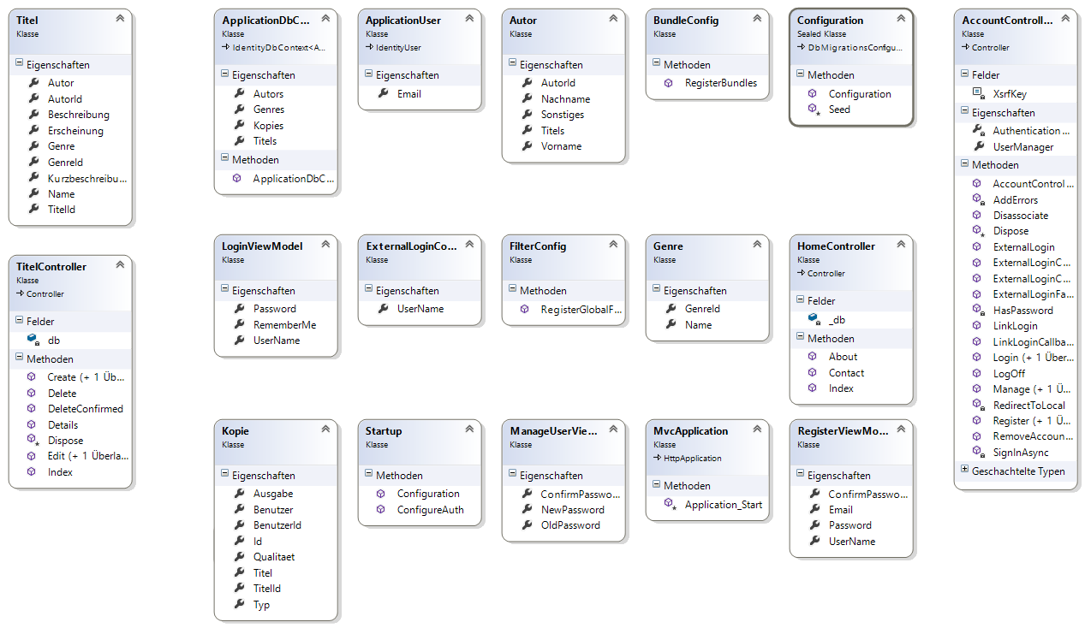

# Process View

N.A.

# Deployment View

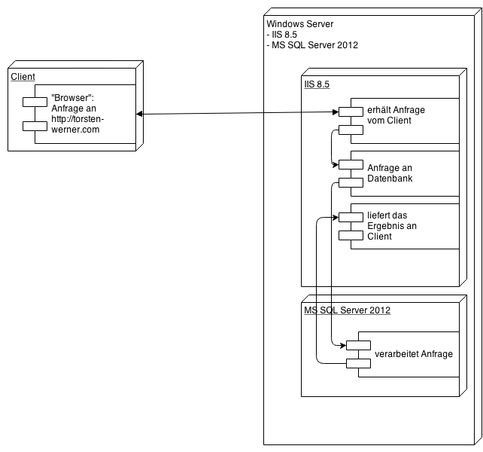

# Data View (optional)

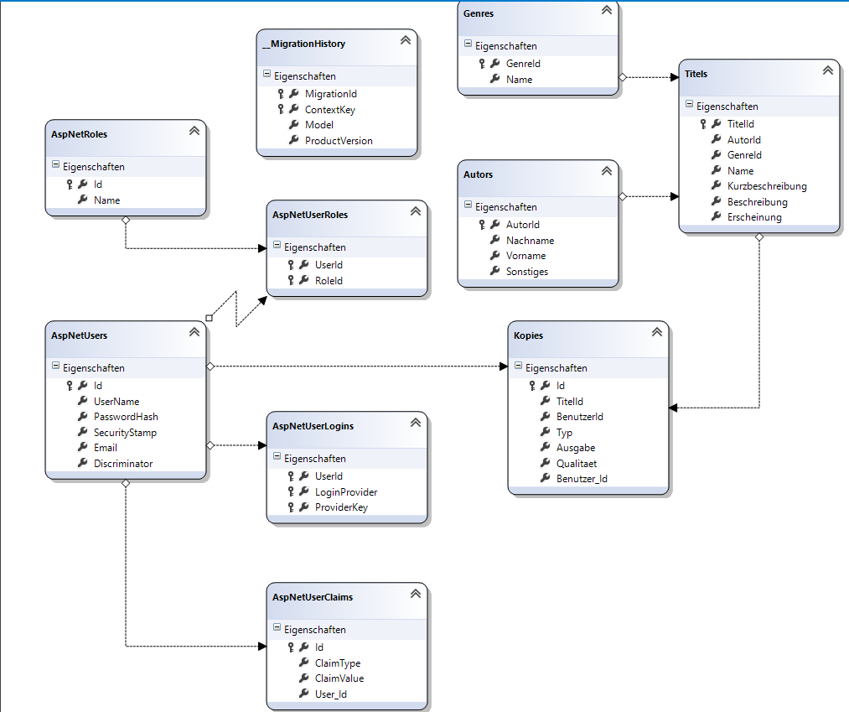

# Size and Performance

[A description of the major dimensioning characteristics of the software that impact the architecture, as well as the target performance constraints.]

WE WILL DO THIS LATER

# Quality

[A description of how the software architecture contributes to all capabilities (other than functionality) of the system: extensibility, reliability, portability, and so on. If these characteristics have special significance, such as safety, security or privacy implications, they must be clearly delineated.]

WE WILL DO THIS LATER